 

Operating procedure and data processing for the pressuremeter test

April 2020

Table des matières

I. General outline of the pressuremeter and added value of this method 1

II. Equipment in our lab 3

III. Assembly manual 3

IV. Preliminary saturation of the probe and the GDS 4

V. Procedure for the calibrations 5

V.1. Unconfined calibration 5

V.2. Confined calibration 6

VI. Pressuremeter test 6

VII. Volume and pressure corrections 9

VII.1. Volume correction 9

VII.2. Pressure correction 10

VIII. Data processing 11

VIII.1. Calculation of the pressuremetric modulus 11

VIII.2. Calculation of the parameter β 12

VIII.3. Calculation of the limit pressure Pl 12

VIII.4. Graphic determination of the creep pressure Pf 15

XI. First observations 16

XI.1. Effects on the limit pressure Pl 17

XI.2. Effects on the pressuremetric modulus EM 17

XI.3. Effects on the creep pressure Pf 17

Table des figures et tableaux

Figure 1: Diagram of the pressuremeter apparatus 1

Figure 2: Focus on the internal mechanism of the probe. 2

Figure 3: Résultats d'essais pressiométriques sur sols traités et non traités après 28 jours et 6 mois (Herrier et al., 2013) 2

Figure 4 : Example of a volume-pressure controller (GDS) 3

Figure 5: Evacuation system of the probe 4

Figure 6: Screen of our GDS 5

Figure 7: Pressuremetric probe and stiff tube for the calibration 6

Figure 8: Example of pre-drilled hole for pressuremeter tests 7

Figure 9: Example of pressuremetric curve before corrections obtained on a 2% cement-treated tank (V60 in cm3 as a function of the pressure in kPa). 8

Figure 10: Example of confined calibration of the probe 9

Figure 11: Example of unconfined calibration of the probe 10

Figure 12: Pressuremetric curves before and after corrections 11

Figure 13: Example of graph for the reverse curve method 13

Figure 14: Example of graph for the hyperbolic extrapolation method 14

Figure 15: Example of a graph to find the creep pressure 15

Figure 16: Positions of the pressuremeter tests in the sand tank (top view) 16

Figure 17: Positions of the pressuremeter tests in the cement-treated sand tank (top view) 16

Tableau 1: Technical specifications of the pressure/volume controller: standard model type 2 GDS instruments ®. 3

Tableau 2: First results of pressuremeter tests on sand and cement-treated sand 17

## General outline of the pressuremeter and added value of this method

The pressuremeter or Pressuremeter Ménard was created by Kôgler in 1934 and redesigned in France in 1955 by Louis Ménard.

The pressuremeter is commonly used to design shallow and deep foundations according to French and European standards NF P 94-261 et NF P 94-262 (Eurocode 7) and to assess soil settlements.

Pressuremeter tests allow to obtain three main characteristics (that will be described more precisely below) through the device shown in Fig.1 and 2

* EM: Pressuremeter Modulus characterizing the pseudo-elastic behavior of a soil
* Pl : Limit pressure defining the strength of a soil
* Pf : Creep pressure which is the limit between pseudo-elastic behavior and plastic phase of a soil

This test is very useful to obtain the deformability of a soil via its modulus. It could provide an interesting link with constitutive models.

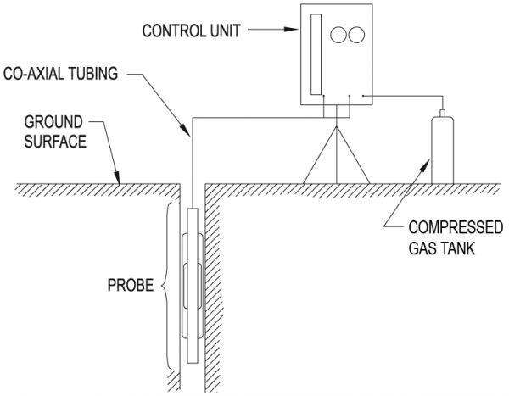

Figure 1: Diagram of the pressuremeter apparatus

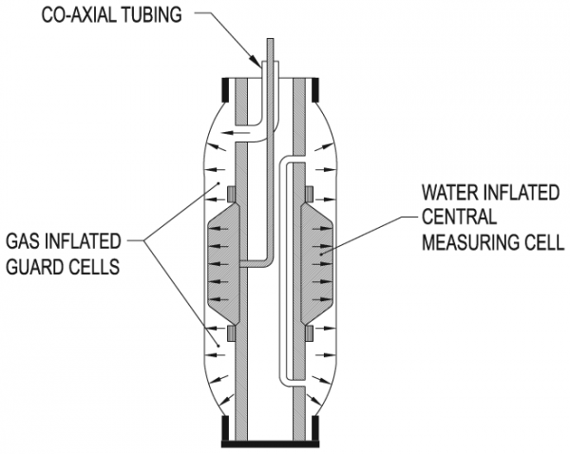

Figure 2: Focus on the internal mechanism of the probe.

In the literature however, only one reference (Herrier et al., 2013) presenting pressuremeter tests’ results on treated soils was found.

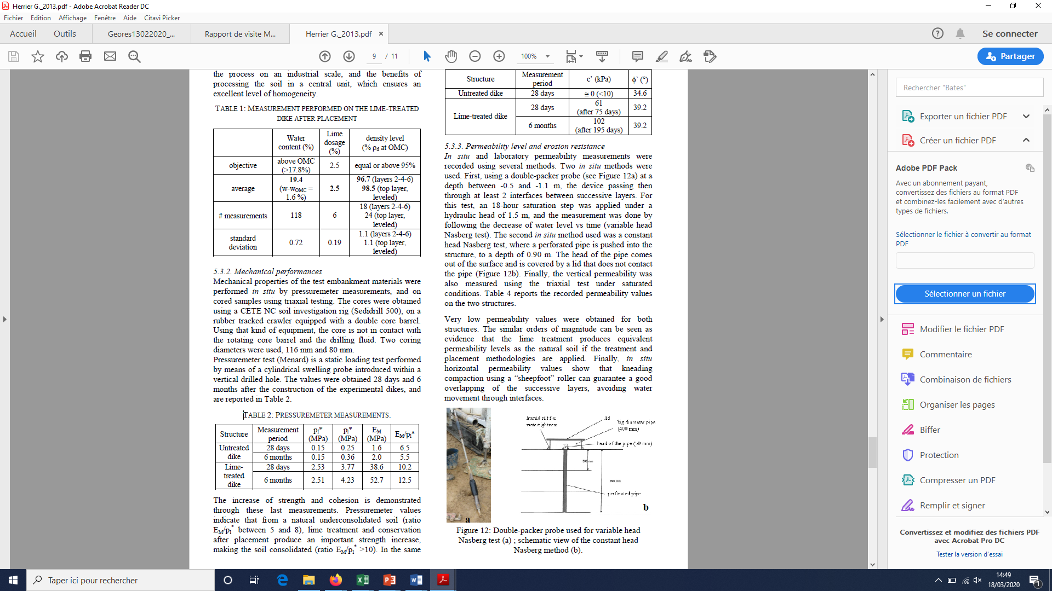

Figure 3: Résultats d'essais pressiométriques sur sols traités et non traités après 28 jours et 6 mois (Herrier et al., 2013)

## Equipment in our lab

* A pressure volume controller

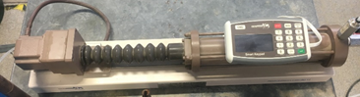

Figure 4 : Example of a volume-pressure controller (GDS)

Tableau 1: Technical specifications of the pressure/volume controller: standard model type 2 GDS instruments ®.

|  |  |
| --- | --- |
| Pressure range | 0-3000 kPa |
| (Nominal) Volume capacity | 200 cm3 |
| Pressure measuring resolution | 1 kPa |
| Volume measuring resolution | 1 mm3 |
| Pressure measurement accuracy | $≤$ 0,15% x 3000 kPa : 4,5 kPa |
| Volume measurement accuracy | $≤$ 0,25 % Measured volume $±$ 30 mm3 |
| Controls in closed loop | Regulation at $±$ 1 kPa and at $±$ 1 mm3 |

* A pressuremetric probe



Figure 5 : Photo of our pressumeremetric probe

* Bottle of dearated water or at least demineralised water

## Assembly manual

GDS must be plugged with the bottle of dearated water (to be able to fill or empty it) and with the probe to inflate it.

To fill (or empty the GDS), press the button “Menu” on the screen then select Fill/Empty.

## Preliminary saturation of the probe and the GDS

Before starting any calibration test or pressuremeter tests, it is necessary to purge out any entrapped air in the tubing.

To this end, a low pressure value can be applied while the bleed screw at the tip of the probe is open as shown is figure 3) and to make sure that the GDS-tubing probe system is full of water. The valve can be screwed when no air bubbles are evacuated.

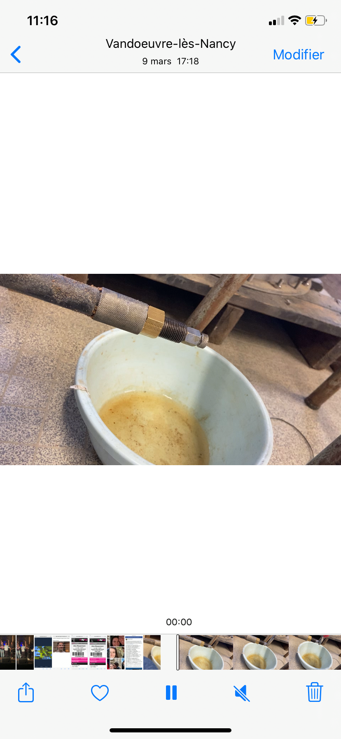

Figure 5: Evacuation system of the probe

## Procedure for the calibrations

There are 2 different tests to do each time before starting a new bench trial.

### V.1. Unconfined calibration

This step is used to correct the pressure.

The process is to inflate the tube at open air up to twice the normal size of the probe (in our case up to 92cm3 read on the screen of the GDS as shown in figure 4 as the probe has a volume of 92cm3).

Reading of the imposed pressure

Reading of the volume injected

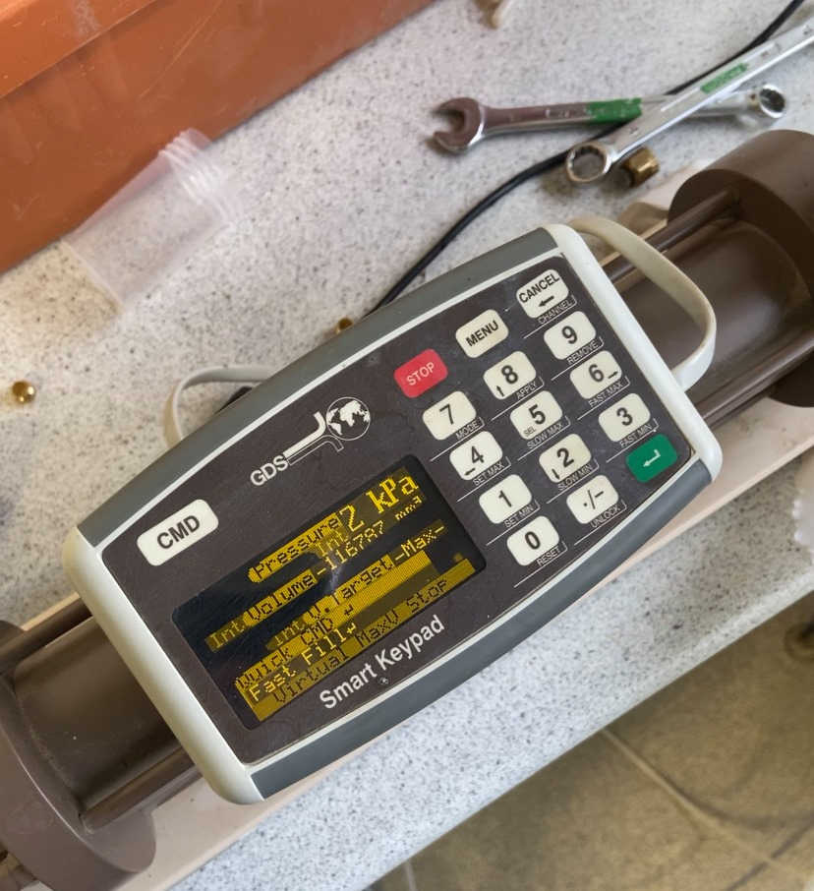

Figure 6: Screen of our GDS

The probe is inflated and the volume read at different level of imposed pressure.

The pressure levels that have been chose are:

10 kPa  
20 kPa  
30 kPa   
50 kPa  
75 kPa  
100 kPa   
150 kPa  
200 kPa  
300 kPa  
  
And then if needed, every 100 kPa.   
  
After having imposed a pressure, wait for the pressure to be stabilized, start measuring time and record the volume at 30 seconds and 60 seconds.

This calibration must be done every time the membrane is changed.

### V.2. Confined calibration

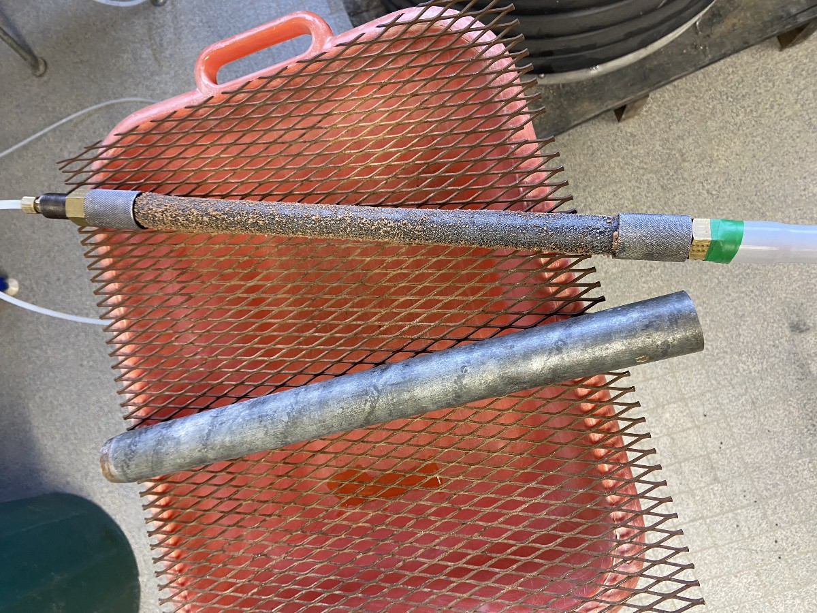

Figure 7: Pressuremetric probe and stiff tube for the calibration

This step is used to correct the volume.

The principle is the same than for the open air calibration, except that the probe is inserted into a stiff tube. The imposed levels are the same and the time of recording too.

This calibration must be carried out for each new serie of tests (when the system is filled with water).

## Pressuremeter test

After the calibration tests, the probe is ready to be used *in situ* or in a tank.

If the soil is treated, the soil should have been drilled before as shown in figure 6 for example.

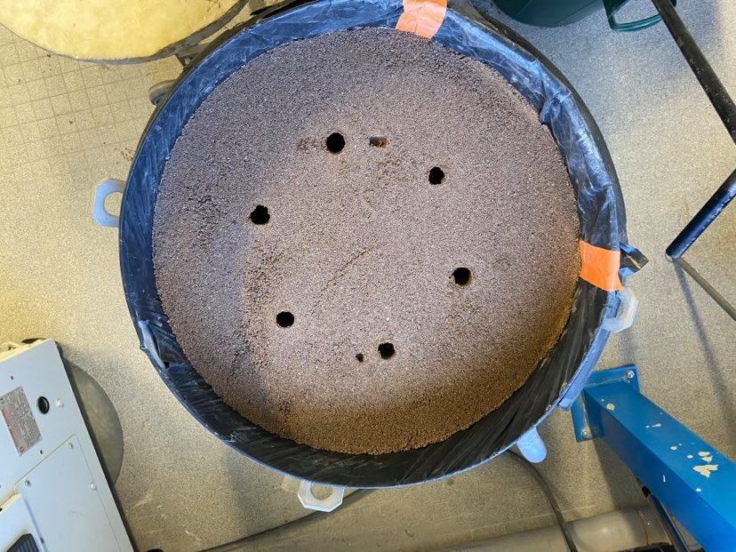

Figure 8: Example of pre-drilled hole for pressuremeter tests

The imposed pressure levels remain the same as in the calibration tests except that the pressure can go way higher (in a 2% cement-treated tank, it can go up to 1030 kPa for instance).   
  
The goal of this test is then to plot the pressuremetric curve as shown in figure 7.

I

II

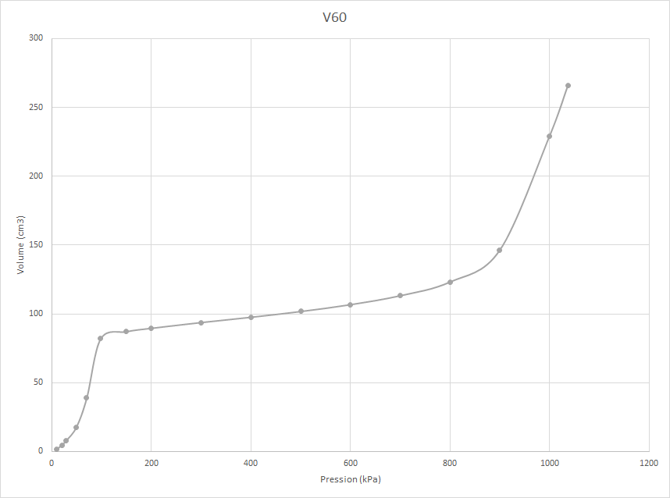

III

Figure 9: Example of pressuremetric curve before corrections obtained on a 2% cement-treated tank (V60 in cm3 as a function of the pressure in kPa).

On the previous graph:

I : contact phase between the probe and the walls of the borehole

II: pseudo-elastic phase

III: large displacements phase

Then the dataset is ready to be corrected.

## Volume and pressure corrections

### VII.1. Volume correction

a

Vc

1

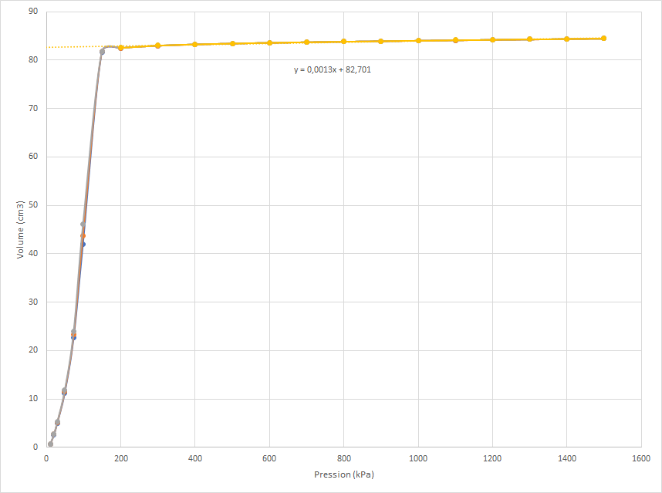

Figure 10: Example of confined calibration of the probe

Then we plot the extension of the line (in yellow on the graph) and we display the equation.

Thanks to this equation that is of the form : ax + b we can find the coefficient a that is the scale of the extension of the linear part.

Then to find the corrected volume, the formula is :

Vr = Vp  - a . Pr

with:

Vr : Corrected volume

Vp : Volume measured during the test

a : Dilatation coefficient of the pressure-volume controller and the tubings

Pr : Pressure applied corresponding to the Vp during the test

Also, we must find the initial volume of the probe Vsc that is equal to :

Vsc = Vs – Vc

With

Vs : Volume of the probe = $\frac{π x d^{2}}{4}$ x $l_{s}$ where d is the diameter of the probe and ls is the length of the probe

Vc is the y-intercept of the extension of the linear part on the graph of the confined calibration.

### VII.2. Pressure correction

Using the open-air calibration of the probe, we find the best-fitting mathemical model such as in figure 11. Normally it would be a 3rd degree polynom as shown in the example below.

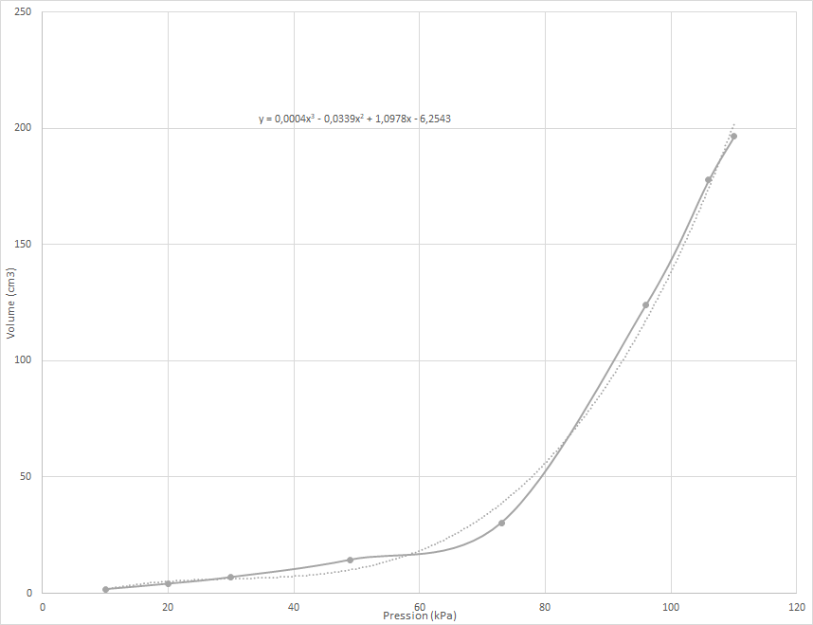

Figure 11: Example of unconfined calibration of the probe

Thanks to this equation we can find the Pressure of the membrane (that we call Pmembrane) if you replace y by the volume measured (V60) during the test, Vp and we solve this equation.

To find the corrected pressure then we subtract Pmembrane to the applied pressure during the test. If the result is negative then we consider that the corrected pressure is equal to 0.

## Data processing

Once we have calculated the corrected volume and pressure we can plot the new volume-pressure graph.

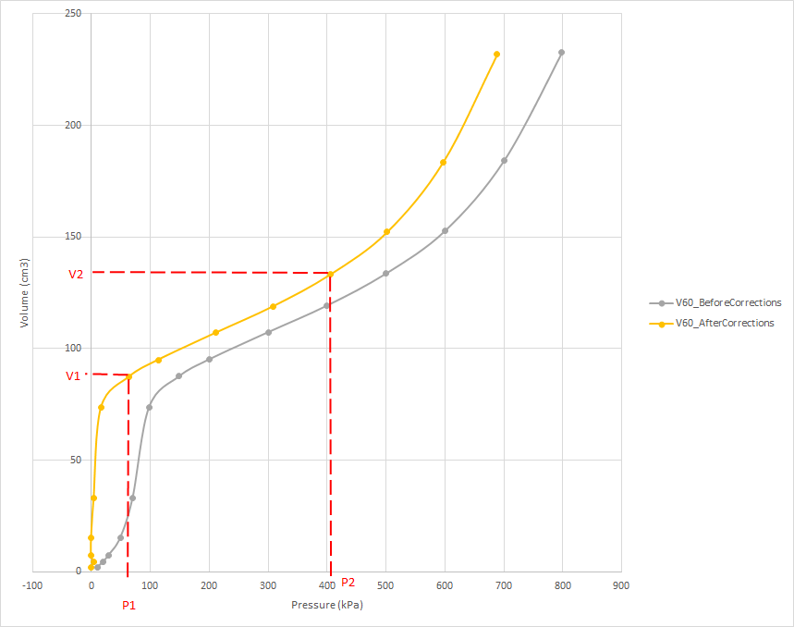

Figure 12: Pressuremetric curves before and after corrections

We have to define the points (V1,P1) and (V2,P2) on the corrected curve. These points delineate the pseudo-elastic phase.

### VIII.1. Calculation of the pressuremetric modulus

According to the ASTM D 4719 standard the pressuremetric modulus is calculated via this formula :

E= EM = 2 (1+v)(V0 + Vm)  *

where

v is the Poisson ratio. It’s value is 0,33

V0 is the volume of the measuring portion of the uninflated probe at 0 volume reading at ground surface, cm3

Vm is the corrected volume reading in the center portion of the $∆$ V volume increase (mean value between V1 and V2)

$∆$ V is the corrected volume increase in the center part of the straight line portion of the pressure-volume curve

$∆$ P is the corrected pressure increase in the center part of the straight line portion of the pressure-volume curve

That is to say in our work:

EM = 2 (1+v)(Vsc + ())  * ()

### VIII.2. Calculation of the parameter β

Then, for each point we must calculate the mi with the formula:

mi = $\frac{{V }_{i corrected} - {V }_{i-1 corrected}}{{P }_{i corrected} - {P }_{i-1 corrected}}$

The lowest value of mi is the me.

VE and PE are the corrected volume and pressure just before the me.

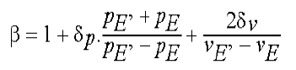

where

$δ_{p}$ : error on the applied pressure

$δ_{v}$ : error on the injected volume

Practically we calculate:

$β$ = 1 + 0,001 $\frac{{PE}_{+1 corrected} + {PE }_{ corrected}}{{PE}_{+1 corrected}- {PE }_{ corrected}}$* + $\frac{3}{{VE}_{+1 corrected}- {VE }_{ corrected}}$

### VIII.3. Calculation of the limit pressure Pl

The Volume limit is calculated with :

Vl = Vsc + 2V1

In the standards 2 methods are described to find the limit pressure :

* Reverse curve method
* Hyperbolic extrapolation method

The limit pressure is the lowest of the 2 values calculated with the 2 methods.

Reverse curve method:

From the point (P2,V2) until the last point of the corrected pressuremetric curve we create a new dataset:

* We take the opposite of the volume $\frac{1}{V corrected x {10}^{-3} }$
* Pressure x 10-3

Then we plot the curve and we plot the best fitting model that is of the form y = Ax +B

Figure 13: Example of graph for the reverse curve method

Thanks to the coefficients A and B we calculate the value of Pli

With:

A : Slope of the linear function V-1 = f(p)  
B : Y-intercept of the linear function V-1 = f(p)

Hyperbolic extrapolation method

From the point following the point (PE, VE) with two parameters that we call X and Y.

* X = $\frac{{(Vcorrected . {10}^{-3})}^{2} - {(VE. {10}^{-3})}^{2}}{Pcorrected . {10}^{-3} - PE. {10}^{-3}}$
* Y = $\frac{{((Pcorrected . {10}^{-3}) . (Vcorrected . {10}^{-3})}^{2}) -(\left(PE. {10}^{-3}\right) . {\left(VE. {10}^{-3}\right)}^{2})}{Pcorrected . {10}^{-3} - PE. {10}^{-3}}$

Then we plot X = f(Y) as shown in the flowing graph and we plot the best fitting model that is of the form y = Cx +D

:

Figure 14: Example of graph for the hyperbolic extrapolation method

We need the coefficients C and D to calculate the Plh

With:

C : Slope of the linear function X= f(Y)  
D : Y-intercept of the linear function X= f(Y)

The Pl in MPa is then the lowest value between Pli and Plh .It is now possible to find the ratio $\frac{E_{M}}{P_{l}}$ that can provides good indication on the strength of the soil.

### VIII.4. Graphic determination of the creep pressure Pf

We have to plot (V60 – V30) = f(Pressure)

The curve is divided in two parts:

* First part (in yellow) on the following graph takes all the points from the beginning of the test to the point (V2,P2)
* The other part are the points from (V2,P2) included to the last points of the test

Then we plot the linear function for each part of the graph. The intersection of the linear functions allow us to read on the x-axis the creep pressure.

Pf

Figure 15: Example of a graph to find the creep pressure

The creep pressure pf is the limit between the pseudo-elastic phase and the large displacement phase of the test. So pf must be greater than p2.

## XI. First observations

One test has been performed on sand and 4 tests have been performed on sand mixed with 2% of cement.

S1

Figure 16: Positions of the pressuremeter tests in the sand tank (top view)

C4

C3

C2

C1

Figure 17: Positions of the pressuremeter tests in the cement-treated sand tank (top view)

Tableau 2: First results of pressuremeter tests on sand and cement-treated sand

|  |  |  |  |  |  |  |
| --- | --- | --- | --- | --- | --- | --- |
| Borehole n° | Treatment | Curing time | EM (MPa) | Pl (kPa) | Pf (kPa) | EM / Pl |
| S1 | None | - | 0,62 | 214 | 190 | 2,89 |
| C1 | 2% cement | 14 days | 4,78 | 900 | 620 | 5,31 |
| C2 | 2% cement | 17 days | 6,24 | 793 | 690 | 7,87 |
| C3 | 2% cement | 17 days | 5,50 | 846 | 690 | 6,5 |
| C4 | 2% cement | 19 days | 2,38 | 829 | 430 | 2,87 |

### XI.1. Effects on the limit pressure Pl

Results are roughly homogenous, with 2% of cement the limit pressure is around 4 times higher than on natural sand.

### XI.2. Effects on the pressuremetric modulus EM

By adding 2% of cement in a sand we can notice that it improves by 4 to 10 times the initial pressuremetric modulus (high variability, repeatability issue?).

The test C4 has a result very surprising compared to the other tests on cemented sand. One possible explanation could be that it has been done between 2 boreholes already tested?

### XI.3. Effects on the creep pressure Pf

To be checked, red means that the creep pressure is lower than P2.